Waste basket

WORKTOOLS - ORGANISATION

Can be placed against a wall or a desk to free up leg room. Combining two bins makes it possible to sort garbage easily.

Features

Semi-circular bin made of recycled materials (100% recycled and recyclable injected plastic resin).
Capacity 16 liters.

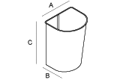
Dimensions

A 254mm x B 254mm x C 381mm.

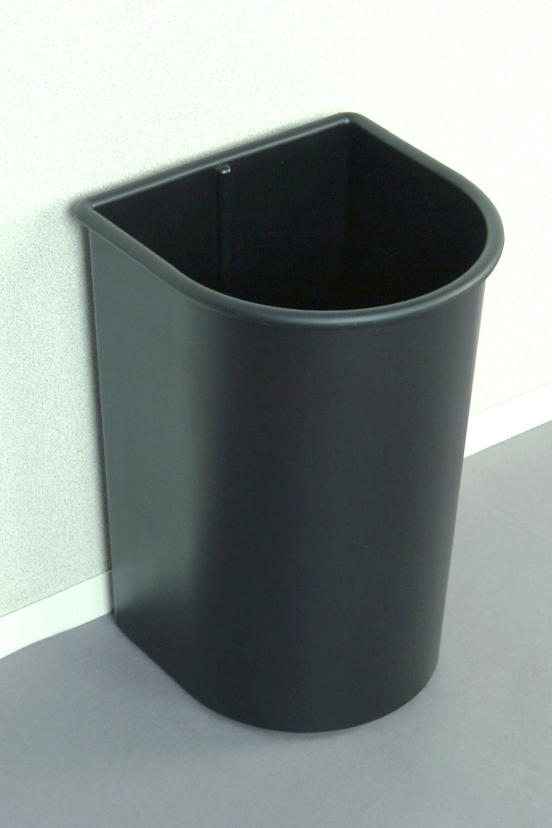
Construction

Injected ABS type plastic.

